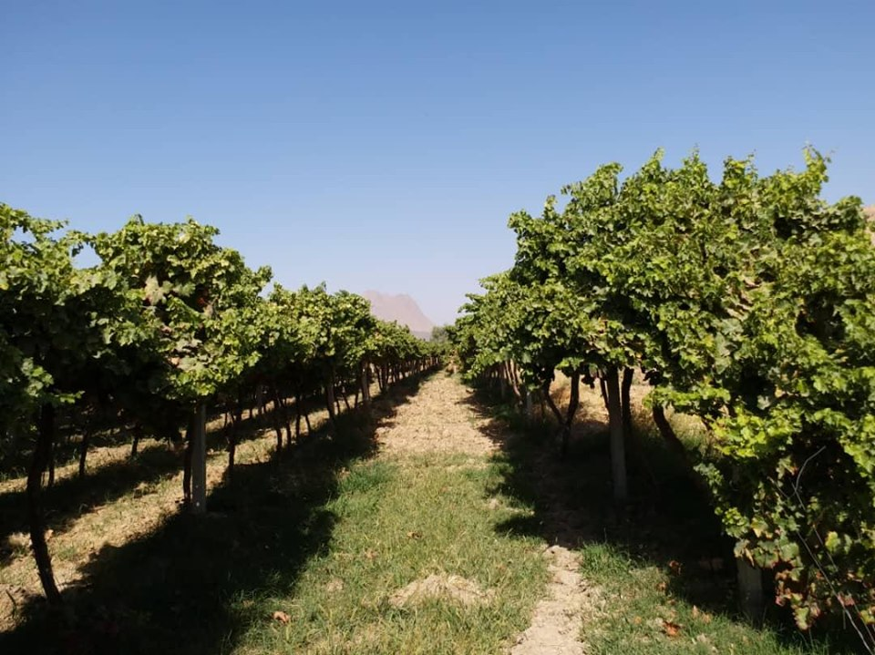
MAIL Builds Over 220 Acres of Fruit Gardens in Parwan
By: Azizullah Popal
The Ministry of Agriculture, Irrigation, and Livestock (MAIL) has built over 220 acres of variety of fruit gardens in Parwan province in 2019.
The National Horticulture and Livestock Program (NHLP) of MAIL has built these gardens in Sayed Khail, Shekh Ali, Jabel Saraj, Bagram, Koh Safi, Shenwari, and Sorkh Parsa districts as well as the provincial capital, Charikar.
The gardens include 2.5 acres of almond garden, 81 acres of apple, 13 of apricot, 34.5 of grapes, 12 of walnut, 4.5 of plum, and 75 acres of persimmon, nectarine and damson gardens.
According to agriculture experts and gardeners, some fruits such as persimmon and nectarine which have just been promoted in Parwan, have given excellent results, and gardeners are more interested in building gardens for these fruits.

Baryalai Ahmadi, promotion staff of the Parwan agriculture directorate, said, “ Fresh fruits such as persimmon, nectarine and peach have given excellent results; it has been years since we work in this area, and we have brought lots of gardeners under ‘ gardening groups’. In the past, their approach was traditional and their gardens faced pests and diseases.”

According to him, the gardens that they have built have regular irrigation system, the seedlings are planted in line-style, have less diseases, get better results, and produce high quality fruits.

“Apart from building gardens for gardeners, we have brought other gardeners under our group and at different times and when needed, we provide training for them. For instance, how to harvest, how to fertilize, how to spray, and when to prune,” Baryalai said.

Ahmadi further stated that peach, early ripening peach and nectarine are the fresh fruits which we have imported from Iran and the weather of Parwan has compatibility with these trees. He said that diseases have not inflicted these trees, has reasonable price and good market, and people’s demand are high for building gardens for these types of fruits.”

Meanwhile gardeners in the province say that their lands yields have increased by 30-40 percent.

Haji Afzal, one of the gardeners of Bagram district, says, “Parwan Agriculture Directorate has built three acres of nectarine and early ripening peach garden for them and have planted 400 trees in it. We harvest 28,000 kilograms of peach from it. We used to cultivate wheat in the past and get less harvest but hopefully we will get 500,000 AFN if the market is good. With the help of the provincial agriculture directorate, we bought spraying machines and built walls for our garden. We hope that we receive more assistance in order to be able to compete with the world. Ten people work in my garden.”

Abdul Sami Noori, head of Parwan agricultural affairs, says, “People interest in building gardens have increased for the province is close to the Capital, Kabul, and has favorable condition for gardeners. Several people come to us on daily basis to get trees and seedlings. We built 221.5 acres of gardens this year based on new methods of gardening, producing excellent results.”

Noori said our aim is to bring changes in the households’ economy, promote trees and new fruits, and produce standard and high quality fruits.

